**COMP1835**

**Lab 3_extra/optional. Working with Redis database**

**Converting JSON into Redis hash and loading mass data**

**Lab 3.9 Convert JASON into Redis Hash (map)**

The below JSON document

{

   "colour":"blue",

   "make":"bmw",

   "model":{

      "trim" : "aero",

      "name" : x3

   },

   "features":[ "powerlocks", "moonroof" ]

}

can be converted into a Redis hash with the following HSET commands for each pair:

> HSET car1 colour blue

> HSET car1 make bmw

> HSET car1 model.trim aero

> HSET car1 model.name x3HSET

> HSET car1 features[0] powerlocks

> HSET car1 features[1] moonroof

> HGETALL car1

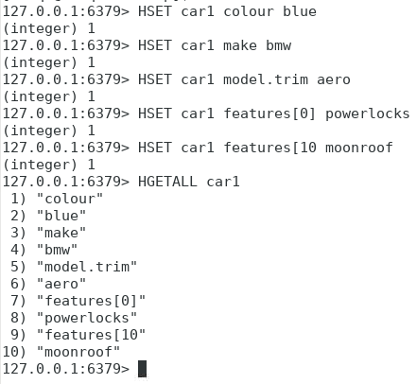

**Lab 3.10 Loading large data set.**

In 2.6 or later versions of Redis the redis-cli utility supports a new mode called pipe mode that was designed in order to perform mass insertion.

First you need to create a text file with multiple SET commands, or HSET, or others for each key, hash, list, etc.

Then you will use the terminal command: **cat file_name | redis-cli --pipe**

Open Text Editor

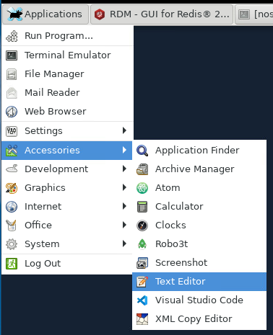

Create file with any number of SET or HSET commands, for example:

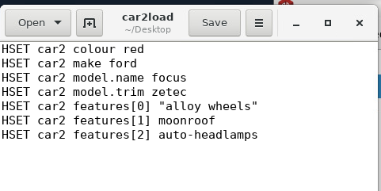

Save it on the Desktop as a text file, called **car2load**

Then open terminal on the Desktop and run the following command:

**cat car2load | redis-cli --pipe**

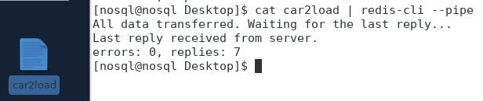

To check that the values have been inserted, you can use HGETALL car2 or navigate to Redis Desktop Manager interface and refresh your connection:

